A Title for a Well-Formatted Full Paper Title Case Times New Roman 14pt Bold (Style Title)

A.N. Author¹, B.N. Another¹ and C.N. Another² (style Author)
¹Dept. of Civil & Environmental Engineering (style affiliation to ‘email address’)
Utah State University
Logan, UT 84321
USA
²Risk Management Center (style affiliation to ‘email address’)
US Army Corps of Engineers
Lakewood, CO 80228
USA
E-mail: corresponding.author@usu.edu

ABSTRACT (style Abstract)

The document below shows you how to lay out your paper for Protections 2025 – 5th International Seminar on Dam Protection Against Overtopping. All you need to do is copy the entire file to your hard disk, print it for reference, overwrite this text with your own and save it as a file bearing the surname of the first author- e.g., AUTHOR.DOC or AUTHOR.DOCX in this case. Your abstract should not exceed 250 words in length; it should not contain artwork. The abstract should present a concise statement of the scope, principal findings, and conclusions of the paper.

Keywords: Up to 6 relevant keywords listed, separated by a comma and a space.

Introduction (Times New Roman Bold 12 ALL Caps – style Heading 1)
Please follow the format of this paper faithfully in order to help ensure that all contributions in the final publication are professional and consistent. Please read through the following instructions before beginning your paper.

The Seminar themes include: Critical issues related to levees and dams; New developments and advanced tools; Overtopping protection systems; System design and performance; Applications and innovative solutions; Case histories of overtopping events; Physical modelling techniques and recent studies; and Numerical modeling methods.

Heading Level 2 (Times New Roman 12 Bold Title Case – style Heading 2)
This text is in Times New Roman 10-point. This template will make it easy to lay out your paper for the proceedings. (style Body Text)

Insert your own text selecting the appropriate style as you go. Be careful when cutting and pasting as sometimes the style is pasted too; be sure to highlight each bit of text and select the right style.

When you have completed your paper, check that you have deleted all instructions and headings in this template.

This template paper is supplied to you in Word format (Word 2003). Text should be single-spaced and fully justified. Styles in this template should ensure that you achieve the correct format with a minimum of effort. All styles used in this document are in pink typeface.

The presenting author should be underlined and the affiliations of all the authors should be given using the numbering system shown above. Email contact details should appear below for the corresponding author.

The paper should be structured into an introduction, main body (arguments, results, discussion, etc.), and a concluding section.

Please remember papers should be no more than 8 to 10 pages in length.

Heading Level 3 (Times New Roman 12 Title Case – style Heading 3)
Do not go beyond three heading levels.

Margins and Page Allowance
Your paper is to be 8.5x11 size with margins as described in Table 1. You should not need to modify either as they are preset in this template.

Table 1. Margins to use in this paper. (style Table caption)

Margin | Size | Size
Left | 25mm | 1in
Right | 25mm | 1in
Top and bottom | 25mm | 1in

For Microsoft Word users the Page Setup Dialog should appear as shown in Figure 1. Center your Figures and Tables. Also center the caption.

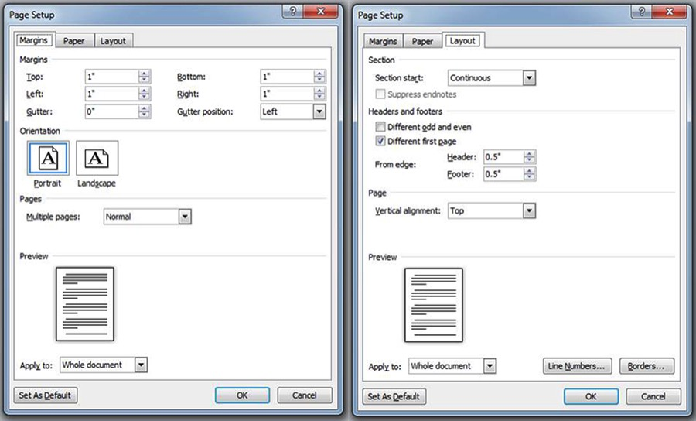
Figure 1. The Page Setup Dialog Box (Margins) for formatting a Protections 2016 paper in MS Word.
(style Caption)

Please DO NOT modify headers or footers. Please DO NOT use page numbers. These will be applied when the proceedings are compiled.

Guidelines for Putting Graphics in your Paper
Graphic objects such as charts, photos and line drawings should be in electronic form and be pasted into the document directly. Floating frames are useful for convenient positioning of graphics. Original line drawings, photos, etc. should be scanned before insertion. If possible, use either PDF or JPEG formatted graphic files, as they are more compact than bitmaps like BMP or PCT. By all means use color if it enhances the meaning of the figures. Number your figures Figure 1, Figure 2, etc. with a short caption under each in 10-point Times New Roman to distinguish it from the main text. The style Caption should be used.

Tables
Tables should be labeled Table 1, Table 2, etc. at the top of each table followed by a table caption. The style TableCaption should be used for the table caption.

Units
Units should be expressed using either the SI system (Système International) or the English System, at the author’s discretion.

Footers and Headers
DO NOT use headers and footers. These will be applied separately when the proceedings are compiled. It is best to avoid footnotes; suggest using parentheses in the text if needed.

Equations
Mathematical equations should be laid out wherever possible using an equation editor and be numbered consecutively as in this example (using the style Equation 10pt Times New Roman italics):

Ij = Sj + σj (3)

where I_{j} is the influence parameter, S_{j} is expected value and σ_{j} is the standard deviation (always explain relevant symbols in the text). A blank line above and below should separate the equation from the text, and the equation number should be right aligned. The equation reference format in the text should be as follows: From Eq. (3), it can be seen that one plus one equals two.

Bullets and Numbering
- If there is no sequence, then use bullet points.
- Bullet points and numbering should be indented.

- Preferably, use standard numbering.
- As per the above point.

ACKNOWLEDGMENTS
This work was conducted in collaboration with the departments of X, Y and Z. Also list here, where applicable, funding sources for the work described and contributors who are not authors to its intellectual content.

REFERENCES
The ASCE journal format should be used for all referencing. References should be presented in the body of the text as follows: Barker (1992) or (Barker 1992) for one author, Jones and Smith (1998) or (Jones and Smith 1998) for two, and Feugard et al. (1994) or (Feugard et al. 1994) for three or more authors. References should be listed in alphabetical order (based on first author) according to the example formats in Section 4. Where the original author’s words are repeated verbatim, references should include the page number for the quote, e.g., ‘… this is the quote’ (Black, 1996: 38). Quotes that are less than three lines should be enclosed in quotation marks. Larger quotes should be placed in a separate paragraph, indented 1.5 cm left and right sides, and use 10pt Times New Roman font. References for large quotes should follow immediately after the quote, right justified and indented 1.5 cm. An example follows.

It is with a great deal of pleasure and excitement that the Organizers invite you to submit a paper for presentation at Protections 2016 – 2nd International Seminar on Dam Protection Against Overtopping, to be held in Fort Collins, Colorado, USA, 7-9 September 2016. (style Quote 10pt Times New Roman)
(Crookston, 2015) (style Quoteline 10pt Times New Roman Italics)

References Placed at the End of the Paper
The general format for references is as follows:

Author’s surname, initials. (Year of Publication). Title in Italics, Name of Publisher, Place of Publication. (style References 10pt Times New Roman)

Some specific examples of reference styles for different publication types are given in the rest of this section.
Journals:
King, S., and Delatte, N.J. (2004). “Collapse of 2000 Commonwealth Avenue: Punching shear case study.” J. Perf. Constr. Facil., 18(1), 54-61.
Conference Proceedings and Symposia:
Fwa, T.F., Liu, S.B., and Teng, K.J. (2004). “Airport pavement condition rating and maintenance-needs assessment using fuzzy logic.” Proc., Airport Pavements: Challenges and New Technologies, ASCE, Reston, Va., 29-38.

Include the sponsor of the conference or publisher of the proceedings, AND that entity’s location— city and state or city and country.
Book References:
Smith, N.J., and Jones, M. (1979). A Companion Guide to Good Authorship, Social Work Press, Sydney.

Book references must include author, book title, publisher, and the publisher’s location. If a specific chapter is being used, list the chapter title and inclusive page numbers. For reports, include the full institution name (not just the acronym) and its location.
Unpublished Material:
Unpublished material is not included in the references. It may be cited in the text in the following forms: (John Smith, personal communication, May 16, 1999) or (Jones et al., unpublished manuscript, 2002). As an exception to the rule, articles that are accepted for publication may be included in the references as follows: Gibson, W. (2003). “Cyberspace: The postmodern frontier.” J. Comp. in Fiction, in press.
Web Pages and On-line Material:
Burka, L. P. (2002). “A hypertext history of multiuser dimensions.” MUD history, <http://www.ccs.neu.edu> (Dec. 5, 2003).

Include an author if possible, a copyright date, a title, the Web address, and the date the material was accessed or downloaded (in parentheses at the end).

Please remember Papers should be no more than 10 pages in length.

Please note that submissions, which do not adhere to the formatting instructions and templates, will not be accepted by the Seminar Organization for inclusion in the proceedings or in the scientific program.

